easyui 的数据网格（DataGrid）可以创建列组合，如下所示：

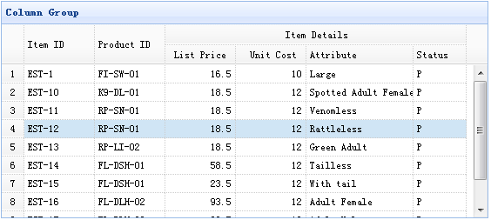

下面的代码实现了上面的实例：

    <table id="tt" title="Column Group" class="easyui-datagrid" style="width:550px;height:250px"

            url="data/datagrid_data.json"

            singleSelect="true"

iconCls="icon-save"

rownumbers="true">

        <thead>

            <tr>

                <th rowspan="2" field="itemid" width="80">Item ID</th>

                <th rowspan="2" field="productid" width="80">Product ID</th>

                <th colspan="4">Item Details</th>

            </tr>

            <tr>

                <th field="listprice" width="80" align="right">List Price</th>

                <th field="unitcost" width="80" align="right">Unit Cost</th>

                <th field="attr1" width="100">Attribute</th>

                <th field="status" width="60" align="center">Stauts</th>

            </tr>

        </thead>

    </table>